**XVII International Symposium on Computer Simulation in Biomechanics**

**July 28th – 30th 2019, Alberta, Canada**

**TWO STOCHASTIC OPTIMAL CONTROL APPROACHES TO SIMULATE HUMAN MOVEMENT –OPTIMAL SOLUTIONS CHANGE WITH ACCURACY OF THE APPROACH**

# Tom Van Wouwe1, Lena H. Ting2,3, Friedl De Groote1

1Department of Movement Sciences, KU Leuven, Leuven, Belgium

2W.H. Coulter Dept. Biomedical Engineering, Emory University and Georgia Institute of Technology, Atlanta, GA, USA

3Department of Rehabilitation Medicine, Emory University, Atlanta, GA, USA

Email: tom.vanwouwe@kuleuven.be

**INTRODUCTION**

Stochastic optimal control has the potential to take our understanding of human movement a step further. It allows taking into account the effect of physiological noise and analyzing robust optimal feedback control solutions rather than open-loop nominal trajectories.

Recently we proposed an approximate deterministic formulation to perform stochastic optimal control simulations of human movement. Such a deterministic formulation allows the application of efficient trajectory optimization techniques to generate solutions. The approximation of the exact stochastic problem occurs at two levels: **(1)** the generally non-Gaussian distribution of the stochastic state trajectories is approximated by Gaussian distributions, allowing a description of the full state space by the mean state $x_{mean}\left(t\right)$ and state covariance $P\left(t\right)$; and **(2)** the discretized propagation of the state-covariance is approximated, through linearization, by the discrete Lyapunov equation:

$$P_{k+1}=A_{k}P_{k}A_{k}^{T}+C_{k}∑_{w}A_{k}^{T}$$

$A_{k}=δ\frac{∂f}{∂x}(x_{k},u_{k},w=0)$, $C_{k}=δ\frac{∂f}{∂w}(x_{k},u_{k},w)$.

which corresponds to the propagation rules applied in the Extended Kalman Filter (EKF).

This approach takes into account the fact that the effect of state uncertainty is different throughout the state-space (non-linearity) leading to different optimal trajectories and control policies depending on the distribution/presentation of sensorimotor noise and musculoskeletal properties.

However, due to the linearization applied to propagate the state-covariance matrix, non-linearities in the dynamics that present themselves around the mean state trajectory are ignored (i.e. the matrices A and C vary non-linearly with the state x, but this behaviour is ignored). Intuitively this means that sudden abrupt changes in the dynamics are not ‘seen’ by using this approach. This approximation can lead to predicting ‘optimal’ behaviour that is far from optimal for the exact stochastic system dynamics. For example, an obstacle will still be very closely avoided because it does not appear in the linearization of the dynamics as long as there is no contact with the obstacle by the mean state trajectory.

An approach that solves this problem and improves approximation **(2)**, is the unscented transform used in the unscented kalman filter (UKF). The non-linear propagation of the mean state trajectory and state-covariance matrix through time is performed based on a deterministic sampling approach.

We demonstrate the difference between the two approaches by focusing on a non-linearity that presents itself in each musculoskeletal simulation: actuator limits (e.g. activations limited between [0 1]). We show that the UKF approach is more exact than the EKF approach (‘EKF’) and that the increased accuracy affects the optimal control policy and state trajectory where the UKF approach predicts antagonistic co-contraction, whereas the EKF approach does not.

**METHODS**

The simulation of the system $f\left(x\left(t\right),u\left(t\right)\right)$ can be discretized using trapezoidal integration: $x_{k+1}=x_{k}+ \frac{δ}{2}\left(f\left(x_{k},u_{k}\right)+f\left(x_{k+1},u_{k+1}\right)\right)=G(x_{k},u_{k},x_{k+1},u_{k+1},δ).$

In the unscented Kalman filter approach (‘UKF’) we discretize the simulation of the stochastic dynamics $f\left(x\left(t\right),u\left(t\right),w\right)$ as follows:

$$P_{k}=L_{k}L_{k}^{T}$$

$$X_{k}=[x_{k} x_{k}+{cL}_{k}{ x}_{k}-cL_{k}]$$

$$Y_{k}=G(X_{k},u_{k},Y_{k},u_{k+1},δ)$$

$$x_{k+1}=W_{m}Y_{k}^{T}$$

$$P_{k+1}={(Y}_{k}-x_{k+1}) W_{c}{{(Y}_{k}-x_{k+1}) }^{T}$$

with L a lower triangular matrix, c a tunable positive scalar, $W_{m}$ the weights to compute the mean and $W_{c}$ the weights to compute the posterior covariance.

The discretized propagation over one time-interval of the mean trajectory and state-covariance can be interpreted as

1. Sampling sigma points
2. Non-linear transformation of the sigma points – i.e. the integration step through the non-linear dynamics
3. Computing the mean and covariance of the transformed sigma points

We simulate an inverted pendulum model ($\ddot{q}=-g.l.sin\left(q\right)+T_{total}$) actuated by two antagonistic ideal torque actuators determined by constant feedforward torque and constant PD feedback: $T^{+}=T_{base}^{+}+K_{p}^{+}\left(q-π\right)+K_{v}^{+}\dot{q}; T^{-}=T_{base}^{-}+K_{p}^{-}\left(q-π\right)+K_{v}^{-}\dot{q}$. The total torque ($T_{total}$) applied to the IP is corrupted by motor noise and clipped between 0 and 250Nm with a smooth but accurate approximation of a clipping function: $T_{total}=f_{clip}\left(T^{+}\right)-f_{clip}\left(T^{-}\right)+T_{noise}),$ with $T_{noise}$ zero-mean Gaussian noise with standard deviation $σ_{noise}$. We solve for $p=[T_{base}^{+},T_{base}^{-},K^{+},B^{+},K^{-},B^{-}]$ that minimize the expected effort $\int{T_{total}^{2}dt}$ and achieve an upright equilibrium posture: $[q, \dot{q},\ddot{q}]=0$, that is stable: $P_{k}=P_{k+1}.$

We solve this stochastic optimal control problem with both the EKF and the UKF approach for increasing $σ_{noise}.$

We compare the control policies of the two approaches (baseline torques and feedback gains). Next, we verify the accuracy of the two approaches by performing a forward simulation (trapezoidal integration with Δt = 0.01s) under the found optimal control policies of 100s. We compute the RMS sway resulting from these forward simulations (‘estimated’) and compare to the RMS sway from the trajectory optimization solution (‘predicted’).

**RESULTS & DISCUSSION**

Because we have a symmetric system around the operation point $[q, \dot{q},\ddot{q}]=0$, the ‘+’ variables ($T_{base}^{+},K_{p}^{+},K_{v}^{+}$) must in a feasible solution be equal to the ‘-’ variables ($T_{base}^{-},K_{p}^{-},K_{v}^{-}$). We therefore only show the ‘+’ variables.

UKF predicts an increasing baseline torque with increasing motor noise to be optimal. EKF does not predict baseline torque. EKF ignores the presence of the strong bending of $f_{clip}$ close to the operating point at $T_{base}^{+}=0.05Nm$, and thus assumes that feedback driven corrections will result in negative torques, allowing for a correction of both $T^{+}$ and $T^{-}$ in case of a deviation from the operating point. UKF, samples around the operating point and detects the saturation at 0Nm. Therefore the operating point is shifted to allow for a correction of both $T^{+}$ and $T^{-}$ in case of a deviation from the operating point.

Feedback gains are different between EKF and UKF. Since UKF detects the saturation of the possible corrective negative torques at 0Nm, larger positive corrections are necessary in the antagonistic torque to correct for a given perturbation compared to EKF where equal positive and negative corrections are assumed possible. Therefore UKF results in larger feedback gains.

Feedback gains in EKF do not change with increasing motor noise and change very slightly in UKF. In EKF the linearization around the operating point results in a redundant feasible set of solutions independent of the amount of motor noise to satisfy the stability constraint ($P_{k}=P_{k+1}$). And thus the same optimal solution is found from this feasible set, independent of motor noise. For the UKF a similar reasoning applies since in the operating region (sway < 3°) the inverted pendulum is practically linear. Therefore only very small changes in optimal feedback gains are found.

Predicted sway is the same for UKF and EKF, and increases with increasing motor noise. However, UKF is much more accurate as can be derived from the difference between the estimated and predicted sway. This difference is very small for UKF but large for EKF. From motor noise with variance 500Nm².s onwards for EKF and for motor noise with variance 5000Nm².s for UKF the estimated sway is >100°. In these simulations the pendulum ‘fell’ and the controller was not able to return the pendulum to the upright position.

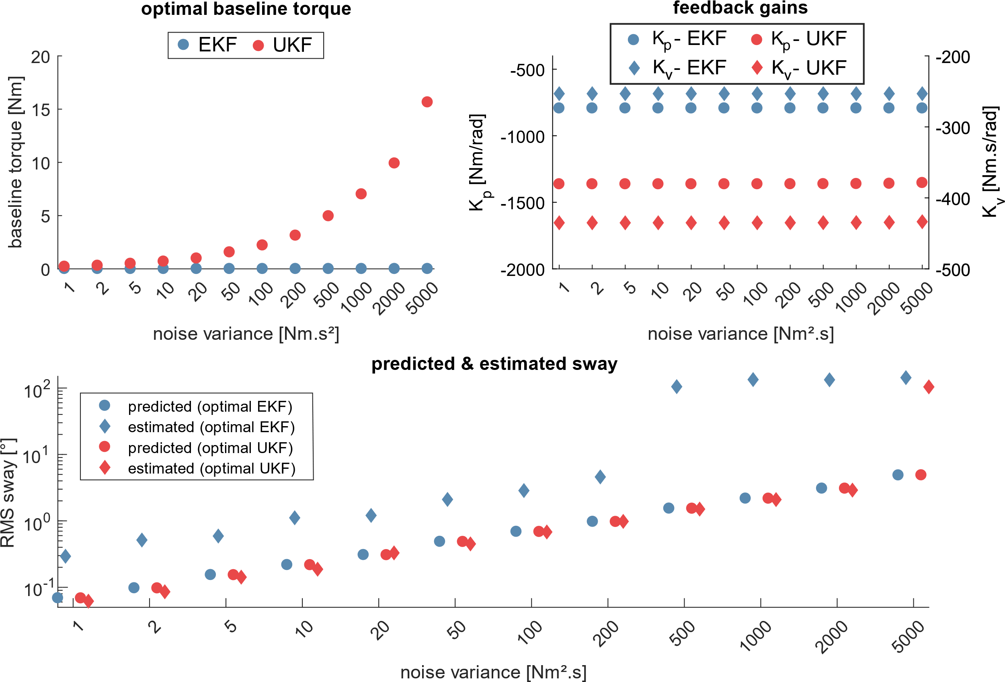

Figure 1 – **Upper left**: Optimal baseline torques ( $T_{base}^{+}$ and $T_{base}^{-}$) predicted by EKF and UKF. **Upper right**: Optimal feedback gains($K_{p}^{+},K_{v}^{+},K_{p}^{+},K_{v}^{+}$) predicted by EKF and UKF. **Lower**: Optimal predicted sway for EKF and UKF and estimated sway from 100s forward simulations, in the presence of the appropriate motor noise, under the predicted optimal controllers by EKF and UKF.

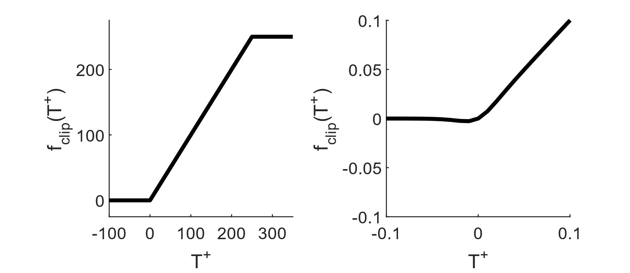

Figure 2 – Clipping function based on tanh functions for smoothing. Left full domain; right zoomed to illustrate the small error introduced by tanh approximations. To make sure the operating point is on the ascending limb we impose $T_{base}^{+}$ and $T_{base}^{-}$ > 0.05Nm.